

**NAME : IMRAN ALI**

**ROLL NO : 110855**

**SEMESTER : THIRD**

**DEPARTMENT : INFORMATION TECHNOLOGY**

**TOPIC : TASK FILES PKT**

**SUBMITTED TO : MISS SAHRISH KHAN**

* + 1. **REPETER CONNECTION OF LAN**

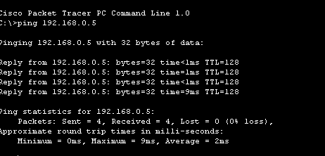**PING RESULT**

IN this network we take one switch one router .

switch is connected with two laptops and a pc is connected with router.

We will assign laptop and pc with IP address and their gate way.

**REPEATER CONNECTION OF CLASS TASK**

**PING RESULT:**

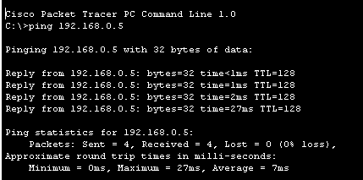

**CONFIGRAUTION:**

First we take a switch and connected it with two pc .

We take a repeater and connected with a single pc .

Then we take a central switch and and connted a switch and repeater with central switch.

**PRACTICAL 3 REPEATER**

**PING RESULT** 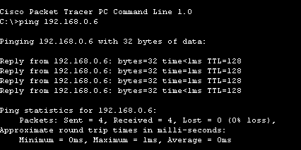

**CONFIGRUATION:**

* + - * 1. First we take two switch and one repeater and connected with a pcs.
        2. Then we take one hub and connected with two pcs .
        3. Then we assign a IP address and gateway to the pcs .

**HOME TASK OF REPEATER**

**Ping result:**

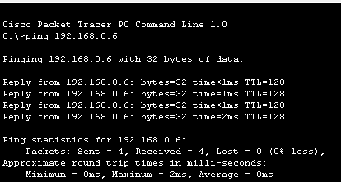

**CONFIGRUATIN :**

* + - * 1. First we take two switch and one repeater and connected with a pcs.
        2. Then we take one hub and connected with two pcs .
        3. Then we assign a IP address and gateway to the pcs.
        4. Then we take a router and connected it with a pc.
        5. Then we will assign a gate way to the router we will
        6. Connected a router with a copper straight through.

**CLASS 1 TASK**

**PING RESULT:**

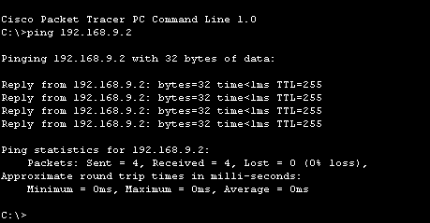

**Configuration :**

* + - 1. First we a take a router switch and two pcs
      2. Then we connected a router with a switch and a switch is connectd
      3. With pc.
      4. Then the router is connected with a pc .
      5. Then we will assign a pc with Ip address and a router with different
      6. Gateway.

**CLASS TASK 2**

**PING RESULT:**

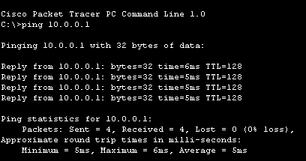

**CONFIGRUATION:**

* + - * 1. First we take switch and connectd with a two pcs.
        2. And the switch is connected with a server.
        3. Then we will assign a address to the pcs .
        4. Then we set a server at DHCP

**Class task 3**

**Ping result :**

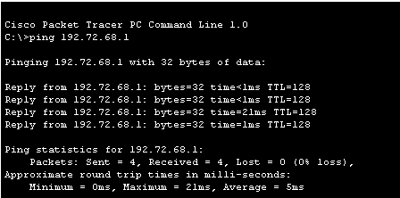

**CONFIGRUATION:**

. first we take a pt repeater and two pcs.

Then we connected these pcs with a wire to a repeater.

Then we give IP address to computer and network start workig.

**Class task 4**

**Ping result:**

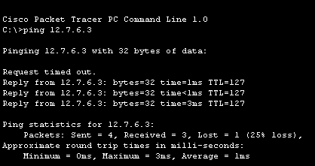

**Configuration:**

* + - 1. In this network we design a wan network with router.
      2. One side we will take 2 pcs and one phone and connected it with switch
      3. Then the switch also connected with another switch.
      4. On the other hand we take switch repeater and hub switch take 2 pcs
      5. Hub and repeater also take one computer and the switch is connected
      6. With a another switch and switch contain another computer
      7. Then we will connected these network with a router .
      8. We will assign a address to the computer and also give gateway.

**Class task 5**

**Ping result :**

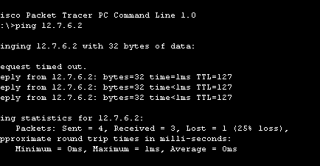

**configuration:**

In this network we design a wan network with router.

One side we will take 2 pcs and one phone and connected it with switch

Then the switch also connected with another switch.

On the other hand we take switch repeater and hub switch take 2 pcs

Hub and repeater also take one computer and the switch is connected

With a another switch and switch contain another computer

Then we add two server on both sides .

Then we will connected these network with a router .

We will assign a address to the computer and also give gateway

**Wan network**

**Ping result**



**Configuration:**

* + - * 1. We will creat a wan network.
        2. We will creat a three lan network using router.
        3. After we will connected these lan network with a routers.
        4. We will assign a address to computers and servers.
      1. And we config the routers also.